R Notebook

library(tidyverse)

## ── Attaching packages ────────

## ✔ ggplot2 3.2.1 ✔ purrr 0.3.2  
## ✔ tibble 2.1.3 ✔ dplyr 0.8.3  
## ✔ tidyr 1.0.0 ✔ stringr 1.4.0  
## ✔ readr 1.3.1 ✔ forcats 0.4.0

## ── Conflicts ─────────────────  
## ✖ dplyr::filter() masks stats::filter()  
## ✖ dplyr::lag() masks stats::lag()

library(sf)

## Linking to GEOS 3.6.1, GDAL 2.1.3, PROJ 4.9.3

library(raster)

## Loading required package: sp

##   
## Attaching package: 'raster'

## The following object is masked from 'package:dplyr':  
##   
## select

## The following object is masked from 'package:tidyr':  
##   
## extract

library(spData)  
library(spDataLarge)  
  
knitr::opts_chunk$set(  
 fig.align = 'center',  
 fig.width = 12,   
 fig.height = 8  
 )

# Vector Data

## simple features

names(world)

## [1] "iso_a2" "name_long" "continent" "region_un" "subregion"  
## [6] "type" "area_km2" "pop" "lifeExp" "gdpPercap"  
## [11] "geom"

world

## Simple feature collection with 177 features and 10 fields  
## geometry type: MULTIPOLYGON  
## dimension: XY  
## bbox: xmin: -180 ymin: -90 xmax: 180 ymax: 83.64513  
## epsg (SRID): 4326  
## proj4string: +proj=longlat +datum=WGS84 +no_defs  
## # A tibble: 177 x 11  
## iso_a2 name_long continent region_un subregion type area_km2 pop  
## <chr> <chr> <chr> <chr> <chr> <chr> <dbl> <dbl>  
## 1 FJ Fiji Oceania Oceania Melanesia Sove… 1.93e4 8.86e5  
## 2 TZ Tanzania Africa Africa Eastern … Sove… 9.33e5 5.22e7  
## 3 EH Western … Africa Africa Northern… Inde… 9.63e4 NA   
## 4 CA Canada North Am… Americas Northern… Sove… 1.00e7 3.55e7  
## 5 US United S… North Am… Americas Northern… Coun… 9.51e6 3.19e8  
## 6 KZ Kazakhst… Asia Asia Central … Sove… 2.73e6 1.73e7  
## 7 UZ Uzbekist… Asia Asia Central … Sove… 4.61e5 3.08e7  
## 8 PG Papua Ne… Oceania Oceania Melanesia Sove… 4.65e5 7.76e6  
## 9 ID Indonesia Asia Asia South-Ea… Sove… 1.82e6 2.55e8  
## 10 AR Argentina South Am… Americas South Am… Sove… 2.78e6 4.30e7  
## # … with 167 more rows, and 3 more variables: lifeExp <dbl>,  
## # gdpPercap <dbl>, geom <MULTIPOLYGON [°]>

plot(world, max.plot = 10)

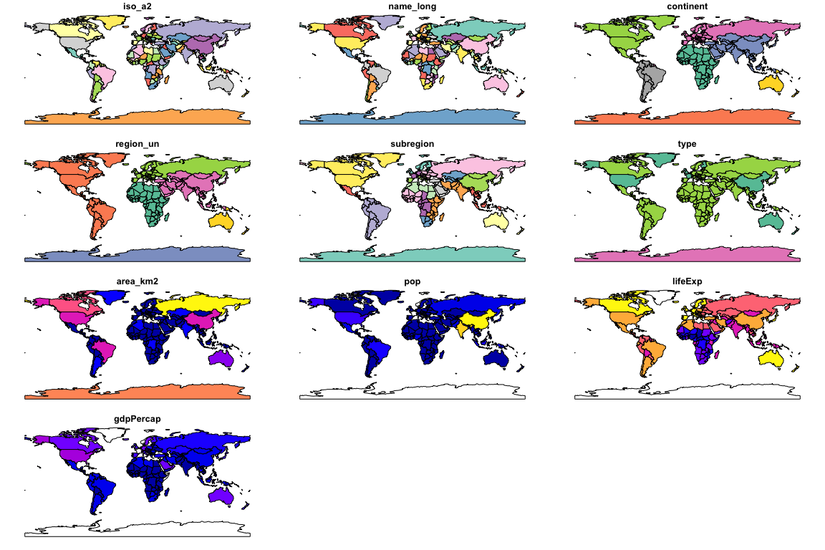

summary(world["lifeExp"])

## lifeExp geom   
## Min. :50.62 MULTIPOLYGON :177   
## 1st Qu.:64.96 epsg:4326 : 0   
## Median :72.87 +proj=long...: 0   
## Mean :70.85   
## 3rd Qu.:76.78   
## Max. :83.59   
## NA's :10

world$geom[[1]]

## MULTIPOLYGON (((180 -16.06713, 180 -16.55522, 179.3641 -16.80135, 178.7251 -17.01204, 178.5968 -16.63915, 179.0966 -16.43398, 179.4135 -16.37905, 180 -16.06713)), ((178.1256 -17.50481, 178.3736 -17.33992, 178.7181 -17.62846, 178.5527 -18.15059, 177.9327 -18.28799, 177.3815 -18.16432, 177.285 -17.72465, 177.6709 -17.38114, 178.1256 -17.50481)), ((-179.7933 -16.02088, -179.9174 -16.50178, -180 -16.55522, -180 -16.06713, -179.7933 -16.02088)))

world_mini = world[1:2, 1:3]  
world_mini

## Simple feature collection with 2 features and 3 fields  
## geometry type: MULTIPOLYGON  
## dimension: XY  
## bbox: xmin: -180 ymin: -18.28799 xmax: 180 ymax: -0.95  
## epsg (SRID): 4326  
## proj4string: +proj=longlat +datum=WGS84 +no_defs  
## # A tibble: 2 x 4  
## iso_a2 name_long continent geom  
## <chr> <chr> <chr> <MULTIPOLYGON [°]>  
## 1 FJ Fiji Oceania (((180 -16.06713, 180 -16.55522, 179.3641 -16…  
## 2 TZ Tanzania Africa (((33.90371 -0.95, 34.07262 -1.05982, 37.6986…

library(sp)  
world_sp = as(world, Class = "Spatial")  
world_sp

## class : SpatialPolygonsDataFrame   
## features : 177   
## extent : -180, 180, -90, 83.64513 (xmin, xmax, ymin, ymax)  
## crs : +proj=longlat +datum=WGS84 +no_defs +ellps=WGS84 +towgs84=0,0,0   
## variables : 10  
## names : iso_a2, name_long, continent, region_un, subregion, type, area_km2, pop, lifeExp, gdpPercap   
## min values : AE, Afghanistan, Africa, Africa, Antarctica, Country, 2416.87048266498, 56295, 50.621, 597.135168986395   
## max values : ZW, Zimbabwe, South America, Seven seas (open ocean), Western Europe, Sovereign country, 17018507.4094666, 1364270000, 83.5878048780488, 120860.06755829

world_sf = st_as_sf(world_sp)  
world_sf

## Simple feature collection with 177 features and 10 fields  
## geometry type: MULTIPOLYGON  
## dimension: XY  
## bbox: xmin: -180 ymin: -90 xmax: 180 ymax: 83.64513  
## epsg (SRID): 4326  
## proj4string: +proj=longlat +datum=WGS84 +no_defs  
## First 10 features:  
## iso_a2 name_long continent region_un subregion  
## 1 FJ Fiji Oceania Oceania Melanesia  
## 2 TZ Tanzania Africa Africa Eastern Africa  
## 3 EH Western Sahara Africa Africa Northern Africa  
## 4 CA Canada North America Americas Northern America  
## 5 US United States North America Americas Northern America  
## 6 KZ Kazakhstan Asia Asia Central Asia  
## 7 UZ Uzbekistan Asia Asia Central Asia  
## 8 PG Papua New Guinea Oceania Oceania Melanesia  
## 9 ID Indonesia Asia Asia South-Eastern Asia  
## 10 AR Argentina South America Americas South America  
## type area_km2 pop lifeExp gdpPercap  
## 1 Sovereign country 19289.97 885806 69.96000 8222.254  
## 2 Sovereign country 932745.79 52234869 64.16300 2402.099  
## 3 Indeterminate 96270.60 NA NA NA  
## 4 Sovereign country 10036042.98 35535348 81.95305 43079.143  
## 5 Country 9510743.74 318622525 78.84146 51921.985  
## 6 Sovereign country 2729810.51 17288285 71.62000 23587.338  
## 7 Sovereign country 461410.26 30757700 71.03900 5370.866  
## 8 Sovereign country 464520.07 7755785 65.23000 3709.082  
## 9 Sovereign country 1819251.33 255131116 68.85600 10003.089  
## 10 Sovereign country 2784468.59 42981515 76.25200 18797.548  
## geometry  
## 1 MULTIPOLYGON (((180 -16.067...  
## 2 MULTIPOLYGON (((33.90371 -0...  
## 3 MULTIPOLYGON (((-8.66559 27...  
## 4 MULTIPOLYGON (((-122.84 49,...  
## 5 MULTIPOLYGON (((-122.84 49,...  
## 6 MULTIPOLYGON (((87.35997 49...  
## 7 MULTIPOLYGON (((55.96819 41...  
## 8 MULTIPOLYGON (((141.0002 -2...  
## 9 MULTIPOLYGON (((141.0002 -2...  
## 10 MULTIPOLYGON (((-68.63401 -...

plot(world[3:6])

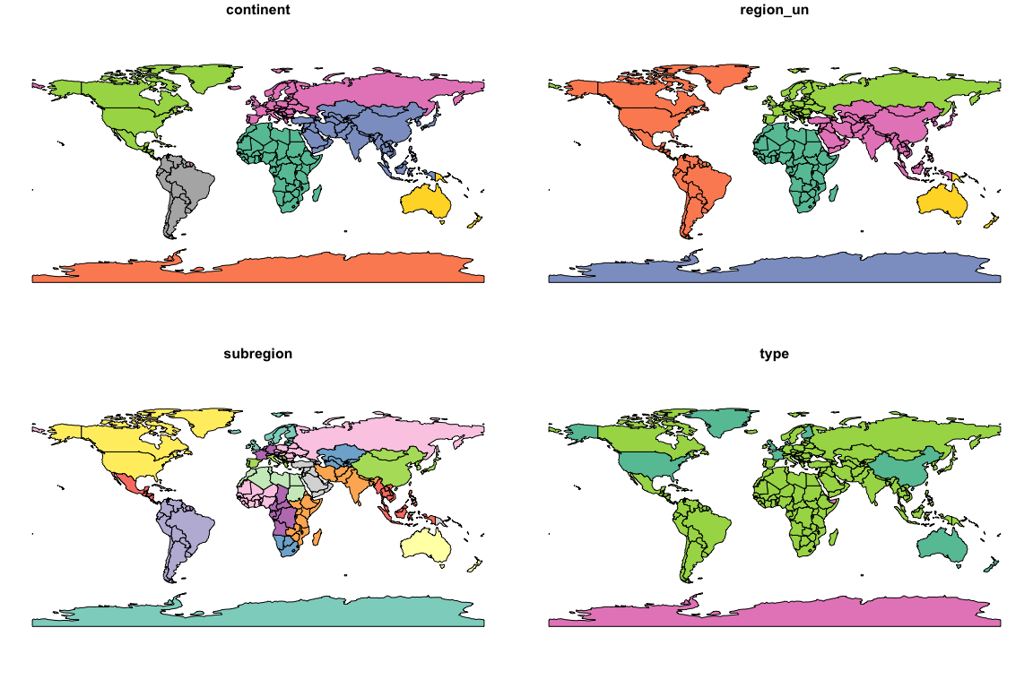

plot(world["pop"])

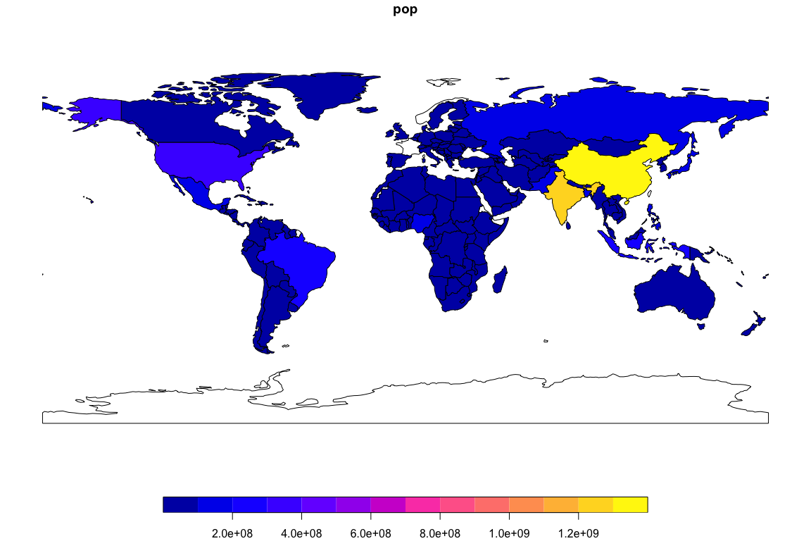

world_asia <- world %>%   
 filter(continent == "Asia")  
  
world_asia

## Simple feature collection with 47 features and 10 fields  
## geometry type: MULTIPOLYGON  
## dimension: XY  
## bbox: xmin: 26.04335 ymin: -10.35999 xmax: 145.5431 ymax: 55.38525  
## epsg (SRID): 4326  
## proj4string: +proj=longlat +datum=WGS84 +no_defs  
## # A tibble: 47 x 11  
## iso_a2 name_long continent region_un subregion type area_km2 pop  
## * <chr> <chr> <chr> <chr> <chr> <chr> <dbl> <dbl>  
## 1 KZ Kazakhst… Asia Asia Central … Sove… 2729811. 1.73e7  
## 2 UZ Uzbekist… Asia Asia Central … Sove… 461410. 3.08e7  
## 3 ID Indonesia Asia Asia South-Ea… Sove… 1819251. 2.55e8  
## 4 TL Timor-Le… Asia Asia South-Ea… Sove… 14715. 1.21e6  
## 5 IL Israel Asia Asia Western … Coun… 22991. 8.22e6  
## 6 LB Lebanon Asia Asia Western … Sove… 10099. 5.60e6  
## 7 PS Palestine Asia Asia Western … Disp… 5037. 4.29e6  
## 8 JO Jordan Asia Asia Western … Sove… 89207. 8.81e6  
## 9 AE United A… Asia Asia Western … Sove… 79881. 9.07e6  
## 10 QA Qatar Asia Asia Western … Sove… 11328. 2.37e6  
## # … with 37 more rows, and 3 more variables: lifeExp <dbl>,  
## # gdpPercap <dbl>, geom <MULTIPOLYGON [°]>

asia = st_union(world_asia)  
asia

## Geometry set for 1 feature   
## geometry type: MULTIPOLYGON  
## dimension: XY  
## bbox: xmin: 26.04335 ymin: -10.35999 xmax: 145.5431 ymax: 55.38525  
## epsg (SRID): 4326  
## proj4string: +proj=longlat +datum=WGS84 +no_defs

## MULTIPOLYGON (((120.295 -10.25865, 118.9678 -9....

plot(world["pop"], reset = FALSE)  
plot(asia, add = TRUE, col = "red")

